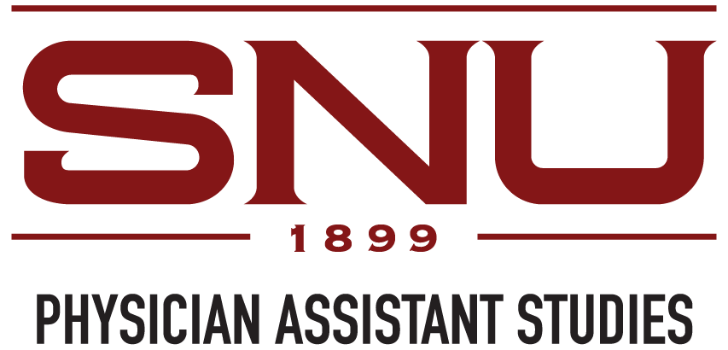

Language Requirements for English as a Second Language Applicants
Due to the fast-paced nature of the PA program and depth of knowledge required for healthcare providers, success in our degree program requires a high level of English language proficiency. English is the language of instruction and examination in the SNU Physician Assistant Program.
If English is not your first language (i.e., is not the first language you learned at home as a child), you will need to provide evidence of adequate English proficiency for admission consideration, unless you qualify for an exemption, as outlined below. This includes all persons born outside of the U.S. including naturalized U.S. citizens, permanent residents, and international applicants.
To demonstrate adequate English proficiency for admission, applicants must take the Test of English as a Foreign Language (TOEFL) internet-based test (iBT). The TOEFL iBT must be taken within the last two years. Students must score an 83 or greater overall, with at least 26 in the speaking component and 20 in all other sections.
An application is not considered to be complete until the University receives official scores from the testing agency. Applicants will not be considered for admission until all documentation is received by the PA Program.
Exemption for Approved Native English-Speaking Countries
The Physician Assistant Program defines an individual who has successfully completed all four years of study at, and graduated from, an accredited high school in an approved English-speaking country as a “first-language” or “native” user of English. Individuals meeting this definition are not required to provide English-language proficiency certification. For a detailed list of approved English-speaking countries, please contact the PA Program at PAadmissions@snu.edu.

